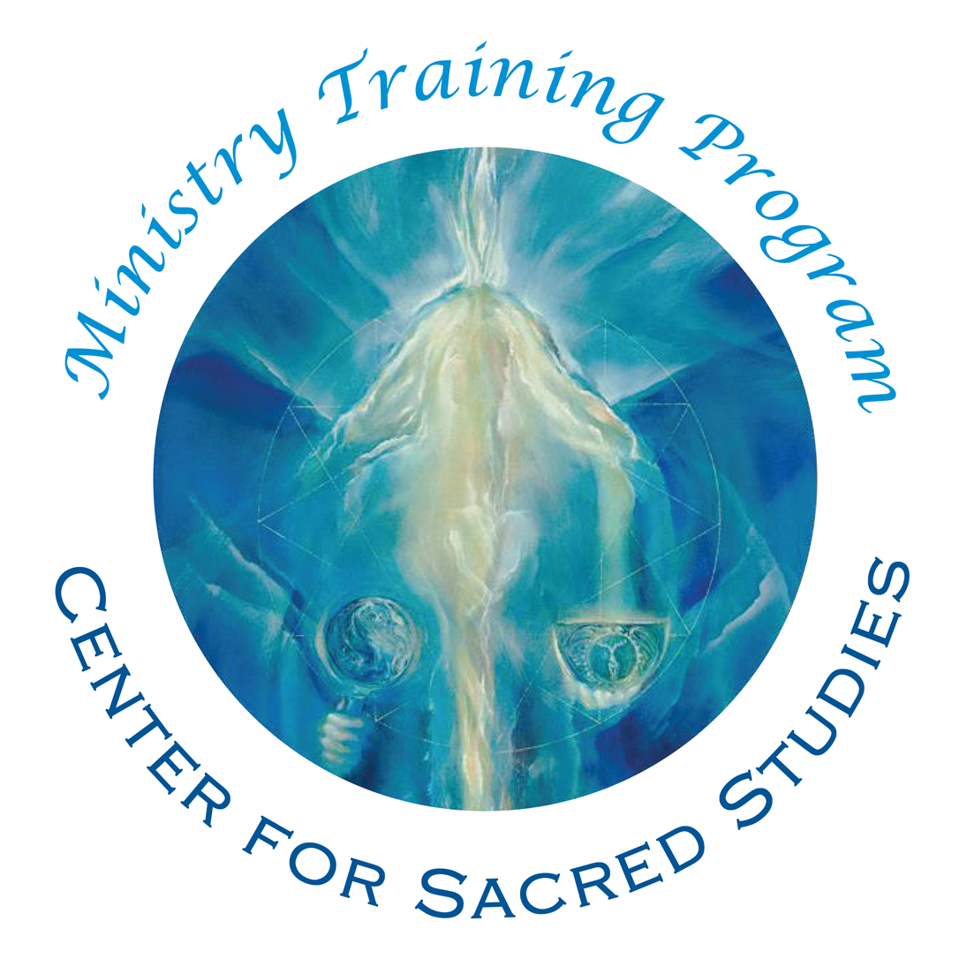

Ministry of Prayer Auditing Registration and
Fees Form
Class of 2024 - starts June 2022

Auditing Tuition $3,000, $1,500/year
Registration by May 15th 2022

Please submit this completed form to enroll in the Ministerial Training Auditing Program. All information you provide is kept confidential and is not shared without your consent.

Contact information: Please type or print clearly using ink.
Name (Last, First, MI) ______________________________________________________________________________________
Address _____________________________________________________________________________________________________
City ________________________________________ State ___________________ Zip _____________ Country ____________
Day Phone ___________________________________ Evening Phone _____________________________________________
Cell Phone ___________________________________ Fax ______________________________________
Email ________________________________________________

Auditing Option $3000 for the 2 year program: Students who elect this option have access to all video and audio material, the monthly conference call dialogue with Darlene and the monthly conference call online with the instructor. Students who audit do not attend breathworks or the yearly retreat, do not have mentors, and are not required to complete the paper assignments. Students who audit do not receive ordination as Ministers of Prayer.
❒ Auditing only – Two installments:
Pay full tuition ($1500) by May 15th of Year One, and pay another $1500 by May 15th of Year Two.

❒ Auditing only – Monthly installments:
Auditing option can also pay automatic monthly fee of $136 if paying by credit card.

Method of Payment for Tuition:
❒ | Check or Money Order (Please make payable to: Center for Sacred Studies)
❒ | Credit Card, to be automatically run according to schedule of selected payment plan.  Visa / Mastercard (please circle)  Card # ________________________________3 Digit Code_________ Expiration Date __________  Cardholder’s Name _________________________________ Signature _________________________

Refund Policy
If you decide to leave the program during the first program year, then you are obligated to complete the payment schedule for that year.
Please initial you have read the above paragraph: __________

For second year tuition, if you notify us of your decision to not continue the program by May 1 (BEFORE the commencement of the second year classes), then you may withdraw without any
further financial obligation. Once the second year program has begun, your payments remain payable for the remainder of the year in accordance with your selected payment option.
Please initial you have read the above paragraph: __________

We understand that circumstances may arise which could make it logistically challenging for you to continue the program. Your holistic wellbeing is an integral part of this program, and therefore it is our policy for withdrawing students to meet with our Educational Program Director, Susan Coleman, before exiting. Our policies are designed to clarify the commitment that you have with the Ministry Training Program..
Please initial you have read the above paragraph: __________

By completing and signing this registration, I attest that I have read and understand the payment and refund policies and that the information provided herein is true and correct.

Signature ____________________________________________________ Date ______________________

