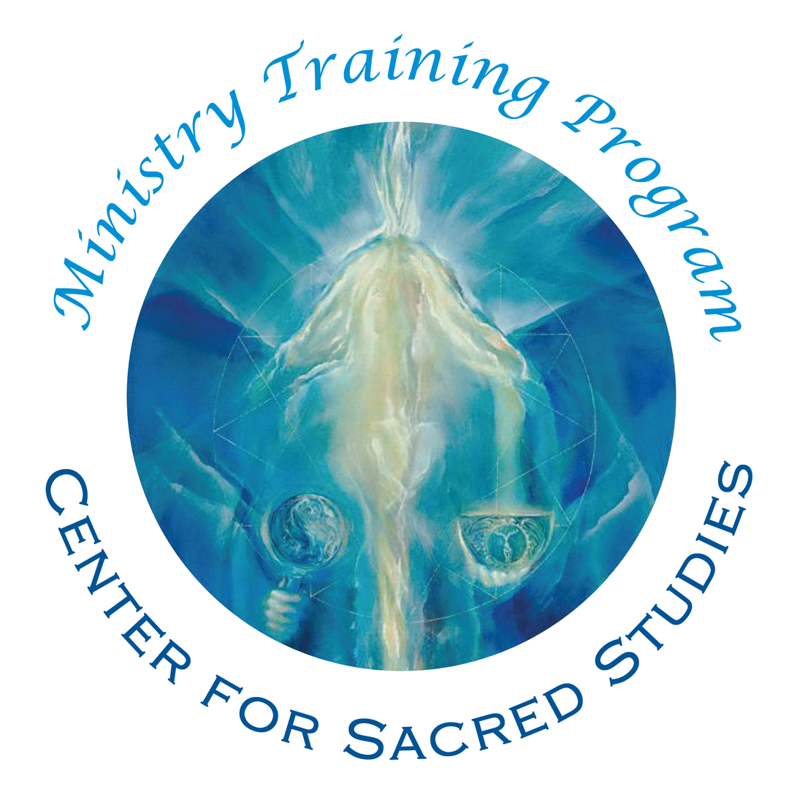

Ministry of Prayer Application

‘To know thyself’ is to know the Divine and the Universe. In this study, you will begin to explore the levels of yourself - the physical, emotional, mental and spiritual. As you prepare yourself to go into self-discovery, it is important to understand that old wounds or repressed energies may surface and need attention. Your answers to questions below will help us better know how to guide the process. All information you provide is kept confidential within the Ministry Training Team.

Contact Registrar at css.minstrytraining@gmail.com with any questions about this Application.

Click here to pay $45 Application fee online:
https://www.paypal.com/cgi-bin/webscr?cmd=_s-xclick&hosted_button_id=BBWVWNDV7GAZE
(if above link does not work, copy/paste link into an open browser window)

Please note: Your application will be processed upon receipt of your application fee.

Center for Sacred Studies • PO Box 2904 • Guerneville, CA 95446

Please enter your information clearly. Attach an additional page if necessary.
Name (Last, First, MI) ________________________________________________________________________________________
Address _______________________________________________________________________________________________________
City _______________________________ State __________ Zip _____________ Country ________________________________
Day Phone ___________________________________ Evening Phone _______________________________________________
Email _______________________________________ Occupation _____________________________________________________

The Center for Sacred Studies is committed to diversity and inclusion and welcomes all applicants equally, including sexual orientation, gender identity, race, culture, ability status, learning differences or any other considerations. Applicants are encouraged to share their pronoun preference and special needs during the application process. The following questions will help us better understand the composition of the class for many reasons, including mentor pairing.

Pronoun Preference ( she/hers, he/his, etc.) _______________________

What is your ethnicity?

- African American/Black
- Asian
- Bi-Racial
- Latinx
- Native American
- Pacific Islander
- White
- MENA (Middle Eastern/North African)
- Other

Birthdate (MM/DD/YYYY) _________________

Tell us about yourself:

1. How did you learn about the Ministry Training Program? ________________________________________________________________________________________________________________________________________________________________________________________________________________________________________________________________________________________________________________________________________________________________________
__________________________________________________________________________________________

2. Why are you interested in this program and what are your reasons for applying at this time?
__________________________________________________________________________________________________________________________________________________________________________________________________________________________________________________________________________________________________________________________________________________________________________________________________________________________________________________________________

3. What has been your spiritual journey up until now? Feel free to attach an additional page if needed.
__________________________________________________________________________________________________________________________________________________________________________________________________________________________________________________________________________________________________________________________________________________________________________________________________________________________________________________________________

4. What is your current spiritual practice?
__________________________________________________________________________________________________________________________________________________________________________________________________________________________________________________________________________________________________________________________________________________________________________________________________________________________________________________________________

5. Describe any experience you have had with spiritual counseling, psychotherapy, or other personal growth work:
__________________________________________________________________________________________________________________________________________________________________________________________________________________________________________________________________________________________________________________________________________________________________________________________________________________________________________________________________

6. Attach a resume, or briefly list your educational and work histories as well as any additional study programs that have contributed to your spiritual growth (e.g., breathwork certification or other applicable trainings).
__________________________________________________________________________________________________________________________________________________________________________________________________________________________________________________________________________________________________________________________________________________________________________________________________________________________________________________________________
7. To better understand your physical and emotional needs, please answer if you are currently experiencing, or have previously experienced, any of the following.

 | Yes | No | If yes, approximately when?
Counseling | _____ | _____ | ______________________________________
Psychotherapy | _____ | _____ | ______________________________________
Breathwork (type) | _____ | _____ | ______________________________________
Psychedelics or mind altering substances  Diagnosed mental illness?  Been in a psychiatric hospital?  Are you on any medications  that affect your emotional, spiritual or cognitive state? | _____  _____  _____  _____ | _____  _____  _____  _____ | ______________________________________  ______________________________________  ______________________________________  ______________________________________

8. Is there anything going on in your life (mental, physical, emotional, spiritual) that may impact your ability to participate in this program that would be important for us to know to support you.
____________________________________________________________________________________________________________________________________________________________________________________________________________________________________________________________________________________________________________________________________________________________________________________________________________________________________________________________________________________
9. Have you experienced a kundalini awakening, spiritual emergence or emergency? If yes, please tell us a little about your experience and when it occurred.
____________________________________________________________________________________________________________________________________________________________________________________________________________________________________________________________________________________________________________________________________________________________________________________________________________________________________________________________________________________
10. Is there any other significant information you want to share regarding your participation in this program?
___________________________________________________________________________________________________________________________________________________________________________________________________________________________________________________________________________________________________________________________________________________________________________
_________________________________________________________________________________________________________________________

11. Please attach one professional/academic and one personal letter of recommendation including their contact information.

By completing and signing this application, I attest that the information provided herein is true and correct.

Signature __________________________________________________________ Date _________________________________________

