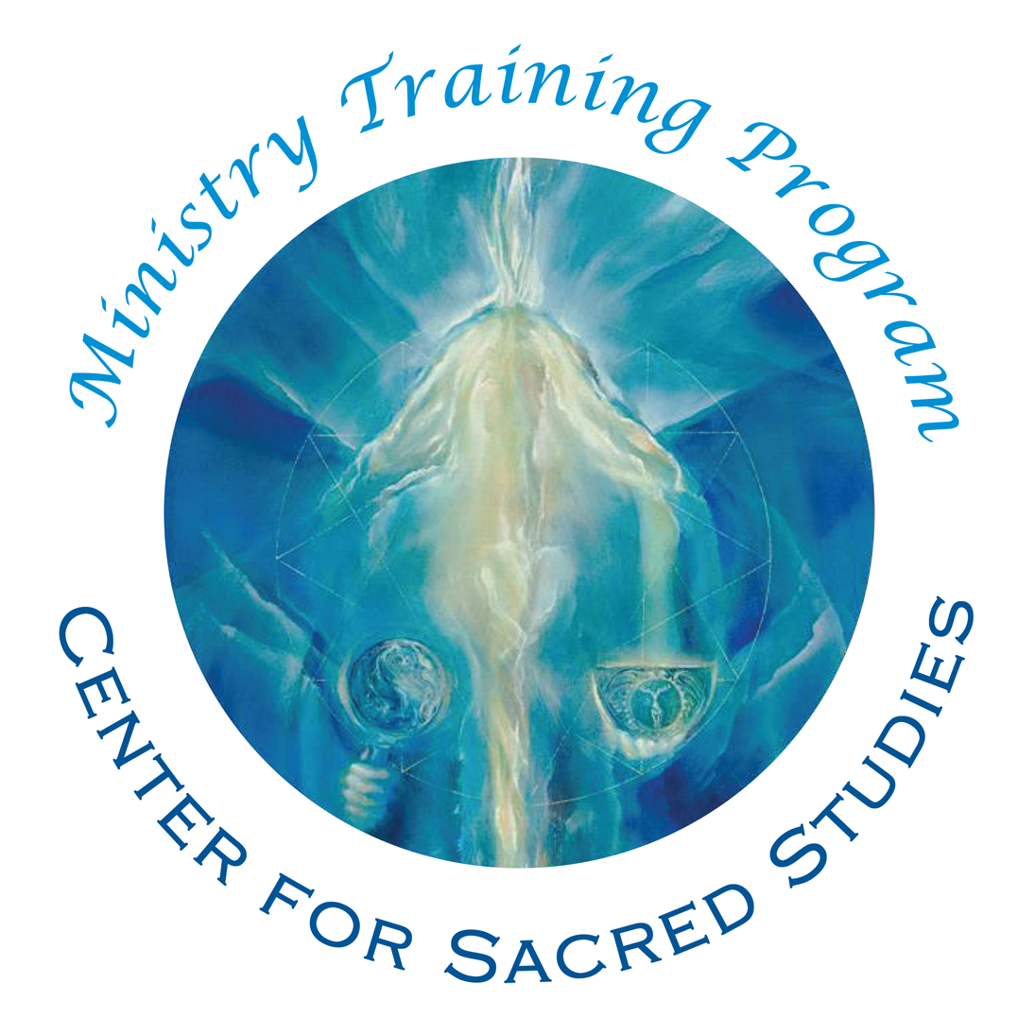

Ministry of Prayer Registration and Fees Form
Class of 2020 - starts May , 2018

Full-time Students -- Register by January 1, 2018
for a $5,000 2-year Tuition Cost - $2500/year

After January 1st, $5,500 2-year Tuition Cost - $2750/year.
For the Auditing Option – no early registration discount.

Please submit this completed form to enroll in the Ministerial Training Program. All information you provide is kept confidential and is not shared without your consent.

Contact information: Please type or print clearly using ink.
Name (Last, First, MI) ______________________________________________________________________________________
Address _____________________________________________________________________________________________________
City ________________________________________ State ___________________ Zip _____________ Country ____________
Day Phone ___________________________________ Evening Phone _____________________________________________
Cell Phone ___________________________________ Fax ______________________________________
Email ________________________________________________

Deposit*:
A non- refundable deposit of $500 is required to secure your space in the program. (No deposit required for the Auditing option)
❒ | Enclosed is my check or money order in the amount of $ _________  Please make payable to: Center for Sacred Studies
❒ | Please charge to Visa / Mastercard (please circle) for the amount of $ _________  Card # ____________________________Expiration Date ___________ 3-Digit Code____________  Cardholder’s Name ____________________________ Signature ______________________________
Click here to pay $500 registration deposit online:
https://secure.cssministryofprayer.org/files/MTPregistrationdeposit.html
(if opening above link on a Mac you may need to copy/paste link into an open browser window)

Payment Plans*: If Registering before January 1st, 2018:
❒ One Installment:
Pay tuition in full (deposit applied) by May 20th of year attending.
 | Tuition | - Deposit |  | = Balance
 | $5000 | $500 |  | $4500
❒ Two Installments:
Pay half of full tuition by May 20th of Year One, and pay balance of tuition by May 20th of Year Two.
Tuition | - Deposit | Due by May 20th Year One | Due by May 20th Year Two
$5000 | $500 | $2250.00 | $2250.00
❒ Four Installments:
After Registration Deposit of $500.00, pay 1/4 of full tuition ($1125.00) by May 20th of Year One, and pay another $1125.00 by November of Year One. Repeat in May and November of Year Two.

❒ Monthly Installments (automatic monthly fee by credit card only):
After Registration Deposit of $500.00, pay $204.54 on the 20th of every month except April, beginning on May 20th of Year One.

If Registering after January 1st, 2018:
❒ | One Installment:  Pay tuition in full (deposit applied) by May 20th of year attending.
 |  | Tuition | - Deposit |  | = Balance
 |  | $5500 | $500 |  | $5000
❒ | Two Installments:  Pay half of full tuition by May 20th of Year One, and pay balance of tuition by May 20th of Year Two.
 | Tuition | - Deposit | Due by May 20th Year One | Due by May 20th Year Two
 | $5500 | $500 | $2500 | $2500
❒  ❒ | Four Installments:  After Registration Deposit of $500.00, pay 1/4 of full tuition ($1250) by May 20th of Year One, and pay another $1250 by November of Year One. Repeat in May and November of Year Two  Monthly Installments (automatic monthly fee by credit card only):  After Deposit of $500.00, pay $227.27 on the 20th of every month except April, beginning on May 20th of Year One.
Auditing Option $2200 for the 2 year program: Students who elect this option have access to all video and audio material, the monthly conference call dialogue with Jyoti and the monthly conference call online with the instructor. Students who audit do not attend breathworks or the yearly retreat, do not have mentors, and are not required to complete the paper assignments. Students who audit do not receive ordination as Ministers of Prayer.

❒ Auditing only – Two installments:
Pay full tuition ($1100) by May 20th of Year One, and pay another $1100 by May 20th of Year Two.

❒ Auditing only – Monthly installments:
Auditing option can also pay automatic monthly fee of $100 if paying by credit card.
Method of Payment for Tuition:
❒ | Check or Money Order (Please make payable to: Center for Sacred Studies)
❒ | Credit Card, to be automatically run according to schedule of selected payment plan.  Visa / Mastercard (please circle)  Card # ________________________________3 Digit Code_________ Expiration Date __________  Cardholder’s Name _________________________________ Signature _________________________
Summary of Program Requirements:
New students and students from a collaborating college or graduate school:
Complete all modules for Year One and Year Two. Participation in two (2) Breathworks is required. Yearly Retreat for both years required. In order to receive ordination, all course material must be complete and all tuition due must be paid by the end of the second year.

Additional Fees
Room and Board for the yearly five-day retreat is charged at the then-current rates and is due upon check in. Breathwork fees depend on the instructor and the location, and are due upon check in. Transportation expenses and study materials are not included in tuition.

Refund Policy
Your $500 deposit is non-refundable. You are registering for a two-year program and tuition commitment. If you decide to leave the program during the first program year, then you are obligated to complete the payment schedule for that year.

For second year tuition, if you notify us of your decision to not continue the program by May 1 (BEFORE the commencement of the second year classes), then you may withdraw without any
further financial obligation. Once the second year program has begun, your payments remain payable for the remainder of the year in accordance with your selected payment option.

We understand that circumstances may arise, which could make it logistically challenging for you to continue the program. Your holistic wellbeing is an integral part of this program, and therefore it is our policy for withdrawing students to meet with our Educational Program Director Rev Hanayo Erza, before exiting. Our policies are designed to clarify the commitment that you and the Ministerial Training Program have to each other.

By completing and signing this registration, I attest that I have read and understand the payment and refund policies and that the information provided herein is true and correct.

Signature ____________________________________________________ Date ______________________

Release of Liability
CSS Ministerial Training Program

Assumption of Risk
I understand and acknowledge that my participation in this study group may expose me to the possibility of emotional or psychological distress and/or other unexpected effects which could manifest physically, emotionally, and/or psychologically. I knowingly choose to participate in this program and assume all responsibility for the consequences of my participation.

Warranty of Physical and Mental Condition
I unequivocally assert that:
- I am in sound physical and mental health.
- I am not now experiencing, nor have experienced in the past year, any serious mental or physical illness or dysfunction.
If there is an exception, please specify: ____________________________________________________

Date of Last Medical Exam (status): _______________________

Due to the experiential nature of parts of the training program, the following information is also requested: Have you ever been subject to any form of seizure, cardiovascular problem, glaucoma, or mental illness? Yes __ No __ If yes, please specify: _______________________________________

Release of Liability
I, _______________________________, hereby voluntarily release Center for Sacred Studies and its staff and associates, from any and all liability or claims which are related to, arise out of, or are in any way connected with my participation in the study group or with any physical or mental condition noted above.

My signature below indicates that I have read this entire document, understand it completely, and agree to be bound by its terms.

___________________________________ __________________
(signature) (date)
___________________________________ __________________
(witness signature) (date)

